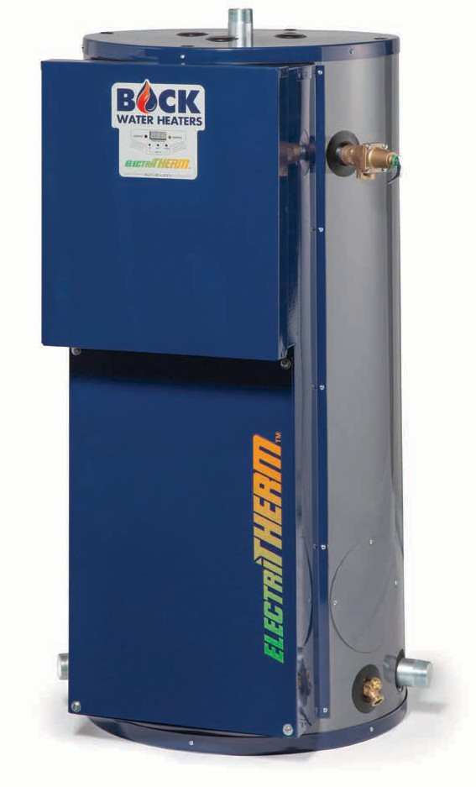

**Job Name Location Arch./Engr. Wholesaler Mech. Contractor Model No. Voltage kW Input Recovery Rate in GPH °F Rise**

**Notes**

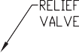

208 V

240 V

277 V

480 V

Input (kW)

1 ɸ

3 ɸ

1 ɸ

3 ɸ

1 ɸ

1 ɸ

3 ɸ

Full Load Current (Amps)

Overcurrent Protection* (Amps)

Full Load Current (Amps)

Overcurrent Protection* (Amps)

Full Load Current (Amps)

Overcurrent Protection* (Amps)

Full Load Current (Amps)

Overcurrent Protection* (Amps)

Full Load Current (Amps)

Overcurrent Protection* (Amps)

Full Load Current (Amps)

Overcurrent Protection* (Amps)

Full Load Current (Amps)

Overcurrent Protection* (Amps)

13.5

64.9

90

37.5

50

56.2

80

32.5

45

48.7

70

28.1

40

16.2

25

15.0

72.1

100

41.6

60

62.5

80

36.1

50

54.1

70

31.2

40

18

25

18.0

86.5

110

50

70

75

100

43.4

60

64

80

37.5

50

21.6

30

24.0

115.4

150

66.7

90

100

125

57.8

80

86.6

110

50

70

28.9

40

27.0

129.8

175

75

100

112.5

150

65

90

97.4

125

56.2

80

32.5

45

30.0

144.2

200

83.3

110

125

175

72.2

100

108.3

150

62.5

80

36.1

50

36.0

173

225

100

125

150

200

86.7

110

129.9

175

75

100

43.3

60

45.0

216.3

300

125

175

187.5

250

108.3

150

162.4

225

93.7

125

54.1

70

54.0

n/a

n/a

150

200

225

300

130

175

194.9

250

112.5

150

65

90

**Input (kW)**

**Input (BTU/hr)**

**Number of Elements**

**Element Wattage (kW)**

**Recovery (GPH & LPH) at Temperature Rise °(F & °C)**

°F

40

60

80

100

120

140

°C

22.2

33.3

44.4

55.6

66.7

77.8

13.5

46,062

3

4.5

GPH

135

90

68

54

45

39

LPH

513

342

256

205

171

147

15.0

51,180

3

5.0

GPH

151

100

75

60

50

43

LPH

570

380

285

228

190

163

18.0

61,416

3

6.0

GPH

181

120

90

72

60

52

LPH

684

456

342

274

228

195

24.0

81,888

6

4.0

GPH

241

161

120

96

80

69

LPH

912

608

456

365

304

260

27.0

92,124

6

4.5

GPH

271

181

135

108

90

77

LPH

1026

684

513

410

342

293

30.0

102,360

6

5.0

GPH

301

201

151

120

100

86

LPH

1140

760

570

456

380

326

36.0

122,832

9

4.0

GPH

361

241

181

145

120

103

LPH

1368

912

684

547

456

391

45.0

153,540

9

5.0

GPH

452

301

226

181

151

129

LPH

1709

1140

855

684

570

488

54.0

184,248

9

6.0

GPH

542

361

271

217

181

155

LPH

2051

1368

1026

821

684

586

**Model**

**Nominal Storage Capacity** gallons (liters)

**Actual Storage Capacity** gallons (liters)

**A**

inches (cm)

**B**

inches (cm)

**C**

inches (cm)

**D**

inches (cm)

**E**

inches (cm)

**F**

inches (cm)

**G**

degrees

**H**

degrees

**I**

degrees

**Shipping Weight** lbs (kg)

CE050-*#

50 (189)

46 (174)

24.00

(61)

49.70

(126)

3.54

(9)

41.91

(106)

17.84

(45)

29.89

(76)

58

57

92

273 (124)

CE080-*#

80 (303)

76 (288)

26.00

(66)

64.50

(164)

3.81

(10)

55.94

(142)

17.84

(45)

32.00

(81)

54

53

72

395 (179)

CE119-*#

119 (450)

108 (409)

30.00

(76)

64.82

(165)

3.79

(10)

55.91

(142)

17.84

(45)

36.80

(93)

50

41

57

521 (236)

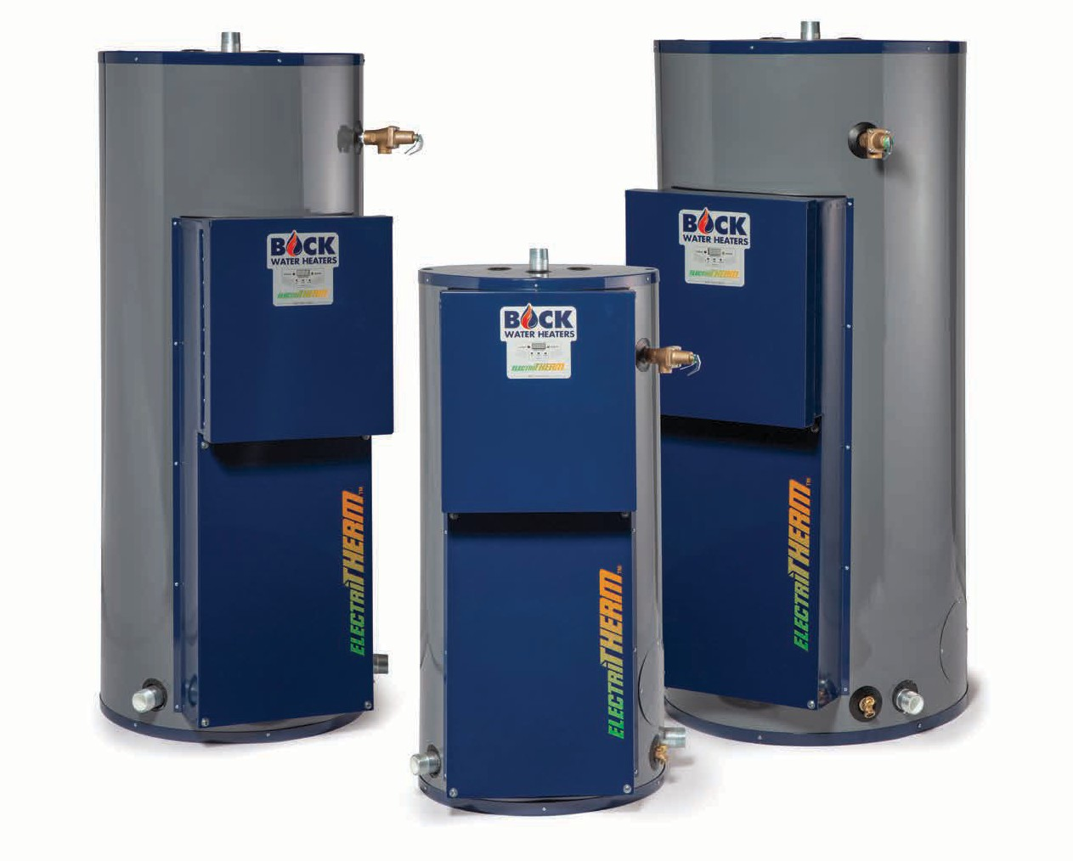

**Location Requirements**

The water heater must be installed indoors. Locate the water heater as close as practical to the water piping system and leave sufficient clearances for servicing the heater. This water heater may be installed on combustible flooring. DO NOT install this water heater on carpeting.

**Clearance From Combustible Materials**

**Recommended Service Clearances**

***BUILT LIKE A BOCK***

**Top**

**Sides (non-piping)**

**Sides**

**(T&P Relief Valve)**

**Front**

**Rear**

**36"**

**4"**

**8"**

**24"**

**0"**

**Top**

**Sides**

**Front**

**Rear**

**0"**

**0"**

**0"**

**0"**

**Submittal Sheet**

**ElectriTHERM™ Water Heater**