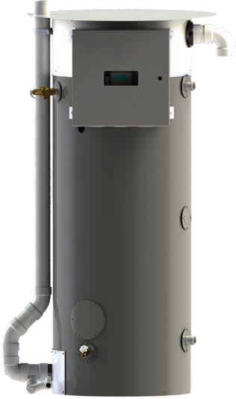

**Job Name Location Arch./Engr. Wholesaler Mech. Contractor Model No. Gas Type BTU/hr Input Recovery Rate in GPH °F Rise**

**Notes**

**Construction**

**ASME**

**Standard**



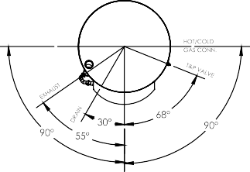

**Submittal Sheet**

**Outdoor OptiTherm® Water Heater**

**Storage, Inputs, Recovery & Efficiency**

***NOTE: ODOT 300/400/500 available with 119 gallon Non-ASME version. NOTE: All OptiTherms available as high altitude models.***

I

I

A

G

C

F

F

H

E

E

D

B

TOP VIEW

FRONT VIEW

ODOT200/ODOT250/ODOT299/ODOT300/ODOT400/ODOT500

***Note: ODOT200/250/299 are Rear Venting***

***ODOT 300/400/500 are Front Venting as Shown***

ODOT125/ODOT150/ODOT199

**Dimensions and Connections**

***NOTE: Change the suffix from “N” to “LP” to designate liquid propane. NOTE: High altitude available up to 5,400 ft, i.e. "-H25"***

***NOTE: “A” denotes ASME construction.***

**T&P valve and brass drain valve factory installed. Standard Voltage (all):** 120V, 60 Hz, 1P

(on selected models)

**Maximum Working Pressure:** 150 psi (1034 kPa)

These models meet or exceed current ASHRAE standards.

NSF/ANSI 5

**Warning:** Installation should be in accordance with all national and/or local codes. In the absence of local codes, refer to NFPA 54 or CSA B149.1.

**Caution:** The recommended maximum hot water temperature setting for normal residential use is 120°F. Bock recommends a tempering valve or anti-scald valve be installed and used according to the manufacturer’s directions to prevent scalding.

***BUILT LIKE A BOCK***

**Model**

**Dimensions in Inches (cm)**

**Cold NPT**

**Hot NPT**

**Recirc. Return NPT**

**Gas NPT**

**Shipping Weight LBS (kg)**

**A**

**B**

**C**

**D**

**E**

**F**

**G**

**H**

**I**

ODOT125N

78.50

(199)

28.00

(71)

63.50

(161)

11.25

(29)

9.19

(23)

62.43

(159)

74.25

(189)

36.43

(93)

80.75

(205)

1.5"

1.5"

1"

3/4"

755

(343)

ODOT150N

78.50

(199)

28.00

(71)

63.50

(161)

11.25

(29)

9.19

(23)

62.43

(159)

74.25

(189)

36.43

(93)

80.75

(205)

1.5"

1.5"

1"

3/4"

755

(343)

ODOT199N

78.50

(199)

28.00

(71)

63.50

(161)

11.25

(29)

9.19

(23)

62.43

(159)

74.25

(189)

36.43

(93)

80.75

(205)

1.5"

1.5"

1"

3/4"

755

(343)

ODOT200N-(A)

67.25

(171)

32.00

(81)

51.53

(131)

11.43

(29)

9.43

(24)

50.18

(127)

62.75

(159)

NA

69.50

(177)

2"

2"

NA

1"

1,195

(542)

ODOT250N-(A)

67.25

(171)

32.00

(81)

51.53

(131)

11.43

(29)

9.43

(24)

50.18

(127)

62.75

(159)

NA

69.50

(177)

2"

2"

NA

1"

1,195

(542)

ODOT299N-(A)

67.25

(171)

32.00

(81)

51.53

(131)

11.43

(29)

9.43

(24)

50.18

(127)

62.75

(159)

NA

69.50

(177)

2"

2"

NA

1"

1,195

(542)

ODOT300N2-(A)

78.80

(200)

32.50

(82)

62.75

(159)

11.40

(29)

9.40

(24)

61.70

(156)

74.00

(188)

36.30

(92)

79.66

(202)

2"

2"

1"

1.5"

1,185

(539)

ODOT400N2-(A)

78.80

(200)

3250

(82)

62.75

(159)

11.40

(29)

9.40

(24)

61.70

(156)

74.00

(188)

36.30

(92)

79.66

(202)

2"

2"

1"

1.5"

1,185

(539)

ODOT500N2-(A)

78.80

(200)

32.50

(82)

62.75

(159)

11.40

(29)

9.40

(24)

61.70

(156)

74.00

(188)

36.30

(92)

39.66

(202)

2"

2"

1"

1.5"

1,185

(539)

**Model**

**Storage GAL (L)**

**Max. Rated Input BTU/HR**

**(KW)**

**Min. Rated Input BTU/HR**

**(KW)**

**Recovery @ 100°F Rise GAL/HR (L/HR)**

**1st Hr. Del. @ 100°F Rise GAL (L)**

**Thermal Efficiency @ Max Input (%)**

**Thermal Efficiency @ Min Input (%)**

ODOT125N

99 (375)

125,000 (36.6)

60,000 (17.6)

144 (545)

213 (806)

96

99

ODOT150N

99 (375)

150,000 (44.0)

60,000 (17.6)

173 (655)

242 (916)

96

99

ODOT199N

99 (375)

199,000 (58.3)

60,000 (17.6)

229 (867)

299 (1,132)

96

99

ODOT200N-(A)

100 (378)

199,999 (58.6)

76,000 (22.3)

228 (863)

298 (1,128)

95

98

ODOT250N-(A)

100 (378)

250,000 (73.3)

76,000 (22.3)

282 (1,067)

352 (1,332)

94

98

ODOT299N-(A)

100 (378)

299,999 (87.9)

76,000 (22.3)

334 (1,264)

404 (1,529)

93

98

ODOT300N2-(A)

125 (473)

300,000 (87.9)

80,000 (23.4)

357 (1,351)

480 (1,817)

99

99

ODOT400N2-(A)

125 (473)

399,999 (117.2)

80,000 (23.4)

466 (1,764)

587 (2,222)

97

99

ODOT500N2-(A)

125 (473)

500,000 (146.5)

80,000 (23.4)

576 (2,180)

696 (2,635)

96

99

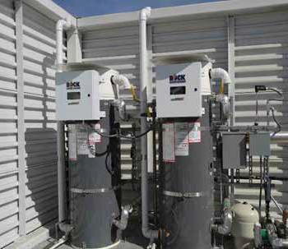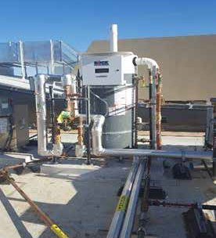

**Venting**

For Outdoor OptiTherm® models, the venting is factory supplied as part of the equipment.

**Gas Pressures (OT125-299)**

***For natural gas:***

MINIMUM GAS SUPPLY PRESSURE (at gas control) = 3.5" W.C. (dynamic)

MAXIMUM GAS SUPPLY PRESSURE (at gas control) = 10.5" W.C. (dynamic) or 14" W.C. (static)

***For LP gas:***

MINIMUM GAS SUPPLY PRESSURE (at gas control) = 8" W.C. (dynamic)

MAXIMUM GAS SUPPLY PRESSURE (at gas control) = 13" W.C. (dynamic) or 14" W.C. (static)

**Note:** Dynamic pressure is measured while gas is flowing and static pressure is measured while gas is not flowing.

**Gas Pressures (OT300-500)**

***For natural gas:***

MINIMUM GAS SUPPLY PRESSURE (at gas control) = 6" W.C. (dynamic)

MAXIMUM GAS SUPPLY PRESSURE (at gas control) = 10.5" W.C. (dynamic) or 14" W.C. (static)

***For LP gas:***

MINIMUM GAS SUPPLY PRESSURE (at gas control) = 8" W.C. (dynamic)

MAXIMUM GAS SUPPLY PRESSURE (at gas control) = 13" W.C. (dynamic) or 14" W.C. (static)

**Note:** Dynamic pressure is measured while gas is flowing and static pressure is measured while gas is not flowing.

Examples of Outdoor OptiTherm Installations

***BUILT LIKE A BOCK***

**Submittal Sheet**

**Outdoor OptiTherm® Water Heater**



**Location Requirements (ODOT 125-500)**

Do not install this water heater under a deck or in a well, stairwell, alcove or other recessed area.

This water heater is only approved for installation in areas that experience sustained temperatures above 32°F and below 120°F. An overnight low or daytime high temperature can only temporarily (<2 hours) be outside of this range. Personal injury or product damage could result under other conditions.

Avoid locating the unit where it is subjected to rain from building runoff drains or water spraying out of hoses or sprinklers. Water may enter vents and damage electrical components.

Locate the heater so it is not subject to physical damage from moving vehicles or flooding.

This water heater cannot be installed directly on the ground. A level platform, made from concrete, brick, or treated wood shall be used underneath this water heater.

Do not install this water heater in an enclosed area that prohibits wind movement around the unit. Wind around the water heater allows combustion exhaust to be carried away and provides fresh combustion air. Avoid installations in corners where an eddy may develop. Eddies can lead to cross-contamination of combustion air and lead to nuisance lockouts and increase maintenance on parts.

To avoid cross-contamination of combustion air, do not locate the water heater in close proximity to other fuel burning equipment exhaust vent terminals. Maintain at least 2 feet of separation between any exhaust vent terminal within in 10 feet of the water heater, it shall be raised to an equal or greater height than the combustion air intake on the water heater.

If possible, in climates of consistent extreme heat (ambient temperature > 100°F), select a location that minimizes extensive exposure to the sun.

**Clearances (ODOT125-199)**

Minimum clearances from combustible construction: 6.5" Left Side, 0" Right Side, 0" Back, 0" Top, 24" Front. 0" from vent connector. Do not install this water heater under an overhang less than 3 feet from its top.

The area under the overhang must be open on 3 sides. Approved for alcove installation and combustible flooring.

Minimum access clearances for servicing: 12" Left Side, 24" Right Side, 0" Back, 24" Top, 24" Front.

**Clearances (ODOT200-500)**

Minimum clearances from combustible construction: 0" Sides, 0" Back, 0" Top, 24" Front.

0" from vent connector. Do not install this water heater under an overhang less than 3 feet from its top.

The area under the overhang must be open on 3 sides. Approved for alcove installation and combustible flooring.

Minimum access clearances for servicing: 12" Left Side, 24" Right Side, 24" Back, 24" Top, 24" Front.

**UL Classified**

UL classified in accordance with NSF/ANSI 372 - *Drinking Water System Components (Lead content)*

to comply with ≤0.25% lead as required by the Reduction of Lead in Drinking Water Act.

UL classified in accordance with NSF/ANSI 5 – *Water Heaters, Hot Water Supply Boilers, and Heat Recovery Equipment.*

***BUILT LIKE A BOCK***

**Submittal Sheet**

**Outdoor OptiTherm® Water Heater**