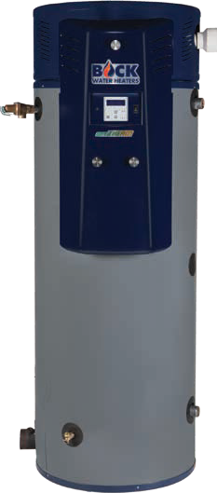Submittal Sheet

OptiTherm® Water Heater
125,000 to 299,000 BTU/hr

Job Name Location Arch./Engr. Wholesaler Mech. Contractor Model No. Gas Type BTU/hr Input Recovery Rate in GPH °F Rise
Notes Construction ASME Standard

OptiTherm® for Optimal Thermal Efficiency:
- Up to 99% thermal efficiency by modulating fuel input to supply variable domestic hot water demand
- Maximum inputs from 125,000 to 299,000 BTU/hr
  - Fully modulating from as low as 60,000 BTU/hr
- 99/100 gallon capacities
- Up to 99% thermal efficiency
- Automatic cathodic corrosion protection system
  - No sacrificial anode rods
- PVC/CPVC/ABS venting - 240' maximum power vent length
- LCD user interface with optional BMS interface
- Ecomate® insulation
- Glass-fused-to-steel water tank and heat exchanger
- SCAQMD certified Ultra-Low NOx
- Natural gas or propane fuel
- Stealth Quiet™ operation
- Fits through a 36-inch door
- Concentric vent kit available
- Five-year limited tank/heat exchanger warranty

Turboflue® High Performance Heat Exchanger:
- Patented helical-fin multi-stage design
- Superior heat conduction and fuel efficiency

Made in the USA

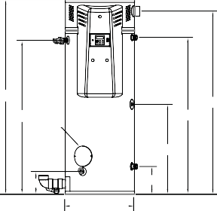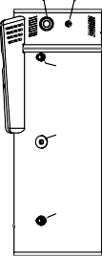Air Intake Gas Conn.
Submittal Sheet
OptiTherm® Water Heater
Air Intake (3” PVC) Gas Conn.
T&P Valve
Hot
A
Return
G
F
C
Hand Hole
H
Drain
E
Cold

D
B
Hot
Return (Plugged)
Cold

125,000 to 299,999 BTU/hr

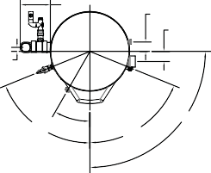Top View
10.82
3.31 Gas Conn.
3.58 Air Intake
Exhaust Vent (3” PVC)
1.42
30º
90º
68º
68º

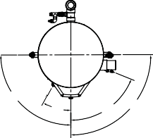Front View Side View
Hot/Cold
Hot/Cold Gas Conn.
90°
30°
68°
90°

OT125/OT150/OT199

Hot

Combustion Air Intake
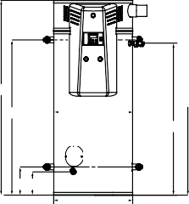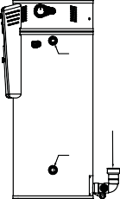 4” PVC
Hot
Exhaust Vent Conn./ Condensate Assembly 4” PVC
Cold
Gas Conn. T & P Valve

A
G
C B
F

Top View

D E
B
Front View

Side View

Storage, Inputs, Recovery & Efficiency
OT200/OT250/OT299

Model | Storage GAL (L) | Max. Rated Input BTU/HR  (KW) | Min. Rated Input BTU/HR (KW) | Recovery @ 100°F Rise GAL/HR (L/HR) | 1st Hr. Del. @ 100°F Rise GAL (L) | Thermal Efficiency @ Max Input (%) | Thermal Efficiency @ Min Input (%)
OT125N | 99 (375) | 125,000 (36.6) | 60,000 (17.6) | 144 (545) | 213 (806) | 96 | 99
OT150N | 99 (375) | 150,000 (44.0) | 60,000 (17.6) | 173 (655) | 242 (916) | 96 | 99
OT199N | 99 (375) | 199,000 (58.3) | 60,000 (17.6) | 229 (867) | 299 (1,132) | 96 | 99
OT200N-(A) | 100 (378) | 199,999 (58.6) | 76,000 (22.3) | 228 (863) | 298 (1,128) | 95 | 98
OT250N-(A) | 100 (378) | 250,000 (73.3) | 76,000 (22.3) | 282 (1,067) | 352 (1,332) | 94 | 98
OT299N-(A) | 100 (378) | 299,999 (87.9) | 76,000 (22.3) | 334 (1,264) | 404 (1,529) | 93 | 98
NOTE: All OptiTherms available as high altitude models.

Dimensions and Connections
Model | Dimensions in Inches (cm) |  |  |  |  |  |  |  | Cold NPT | Hot NPT | Recirc. Return NPT | Gas NPT | Air Intake PVC | Exhaust Vent PVC | Shipping Weight LBS (kg)
 | A | B | C | D | E | F | G | H
OT125N | 78.50  (199) | 28.00  (71) | 63.50  (161) | 11.25  (29) | 9.19  (23) | 62.43  (159) | 74.25  (189) | 36.43  (93) | 1.5" | 1.5" | 1" | 3/4" | 3" | 3" | 670  (304)
OT150N | 78.50  (199) | 28.00  (71) | 63.50  (161) | 11.25  (29) | 9.19  (23) | 62.43  (159) | 74.25  (189) | 36.43  (93) | 1.5" | 1.5" | 1" | 3/4" | 3" | 3" | 670  (304)
OT199N | 78.50  (199) | 28.00  (71) | 63.50  (161) | 11.25  (29) | 9.19  (23) | 62.43  (159) | 74.25  (189) | 36.43  (93) | 1.5" | 1.5" | 1" | 3/4" | 3" | 3" | 670  (304)
OT200N-(A) | 67.25  (171) | 32.00  (81) | 51.53  (131) | 11.43  (29) | 9.43  (24) | 50.18  (127) | 62.75  (159) | NA | 2" | 2" | NA | 1" | 4" | 3" | 1,110  (503)
OT250N-(A) | 67.25  (171) | 32.00  (81) | 51.53  (131) | 11.43  (29) | 9.43  (24) | 50.18  (127) | 62.75  (159) | NA | 2" | 2" | NA | 1" | 4" | 3" | 1,110  (503)
OT299N-(A) | 67.25  (171) | 32.00  (81) | 51.53  (131) | 11.43  (29) | 9.43  (24) | 50.18  (127) | 62.75  (159) | NA | 2" | 2" | NA | 1" | 4" | 3" | 1,110  (503)

NOTE: Change the suffix from “N” to “LP” to designate liquid propane. NOTE: “A” denotes ASME construction.
T&P valve and brass drain valve factory installed. Standard Voltage (all): 120V, 60 Hz, 1P
Maximum Working Pressure: 150 psi (1034 kPa) These models meet or exceed current ASHRAE standards.

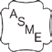
NSF/ANSI 5

Warning: Installation should be in accordance with all national and/or local codes. In the absence of local codes, refer to NFPA 54 or CSA B149.1.
Caution: The recommended maximum hot water temperature setting for normal residential use is 120°F. Bock recommends a tempering valve or anti-scald valve be installed and used according to the manufacturer’s directions to prevent scalding.

125,000 to 299,999 BTU/hr

Venting (Materials)
Submittal Sheet
OptiTherm® Water Heater

The following materials are approved for use as the vent and combustion air intake piping:
- PVC (DWV, ASTM-D2665 or CSA B181.2)
- PVS (Schedule 40, ASTM-D1785 or CSA B137.3)
- PVC (SDR Series, ASTM-D2241 or CSA B137.3)
- CPVC (Scedule 40, ASTM-F441 or CSA B137.3)
- CPVC (SDR Series, ASTM-F442)
- ABS (Schedule 40, DWV, ASTM-D2661 or CSA B181.1)
NOTE: Use of cellular core PVC (ASTM F891), cellular core CPVC, or Radel (polyphenyl-sulfone) in non-metallic venting systems is prohibited.
Covering non-metallic vent pipe and fittings with thermal insulation is prohibited. In Canada, check local codes to ensure that SDR series is approved for use,
SDR is not approved for all installations in Canada.

The following materials are approved for use for the fittings in the vent and combustion air intake systems:
- PVS (Schedule 40 DWV, ASTM D2665)
- CPVC (Scedule 40, ASTM F438)
- ABS (Schedule 40, DWV, ASTM D2661)

Venting (SystemLengths)
Minimum and Maximum Vent Lengths - 3" / 4" Pipe
Model | Pipe Arrangement | Minimum Equivalent Pipe Length (per pipe run) |  | Maximum Equivalent Pipe Length (per pipe run)
 |  | Air Intake (ft) | Vent (ft) | Air Intake (ft) | Vent (ft)
OT125/OT150/ OT199 | Direct Vent (2 Pipe) | 18/50 | 18/50 | 50/120 | 50/120
 | Power Vent (1 Pipe) | 0/0 | 18/100 | 0/0 | 100/240
OT200/OT250/ OT299 | Direct Vent (2 Pipe) | 15/50 | 15/50 | 50/120 | 50/120
 | Power Vent (1 Pipe) | 0/0 | 15/50 | 0/0 | 100/240

Venting (Equivalent Length)
The equivalent straight pipe length of a 90°, 1/4 standard bend elbow and 45°, 1/8 standard bend elbow is 5 feet and 2.5 feet, respectively.
DO NOT use short bend elbows.

Gas Pressures (OT125-299)

For natural gas:
MINIMUM GAS SUPPLY PRESSURE (at gas control) = 3.5” W.C. (dynamic)
MAXIMUM GAS SUPPLY PRESSURE (at gas control) = 10.5” W.C. (dynamic) or 14” W.C. (static)

For LP gas:
MINIMUM GAS SUPPLY PRESSURE (at gas control) = 8” W.C. (dynamic)
MAXIMUM GAS SUPPLY PRESSURE (at gas control) = 13” W.C. (dynamic) or 14” W.C. (static)
Note: Dynamic pressure is measured while gas is flowing and static pressure is measured while gas is not flowing.

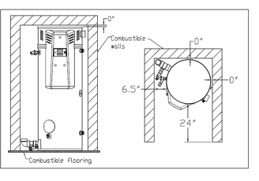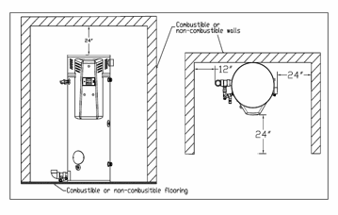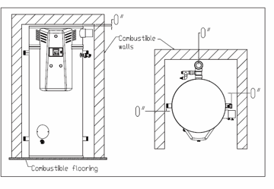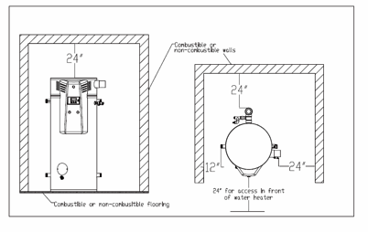

125,000 to 299,999 BTU/hr
Submittal Sheet
OptiTherm® Water Heater

UL Classified
UL classified in accordance with NSF/ANSI 372 - Drinking Water System Components (Lead content) to comply with ≤0.25% lead as required by the Reduction of Lead in Drinking Water Act.
UL classified in accordance with NSF/ANSI 5 – Water Heaters, Hot Water Supply Boilers, and Heat Recovery Equipment.

Clearances (OT125-199)
Minimum clearances from combustible construction: 6.5" Left Side, 0" Right Side, 0" Back, 0" Top, 24" Front. 0" from vent connector. Approved for alcove installation and combustible flooring.
Minimum access clearances for servicing: 12" Left Side, 24" Right Side, 0” Back, 24" Top, 24" Front.

Minimum Clearance From Combustibles Required Minimum Access Clearances

Clearances (OT200-299)
Minimum clearances from combustible construction: 0" Sides, 0" Back, 0" Top, 24" Front. 0" from vent connector. Approved for alcove installation and combustible flooring.
Minimum access clearances for servicing: 12" Left Side, 24" Right Side, 24" Back, 24" Top, 24" Front.

Minimum Clearance From Combustibles Required Minimum Access Clearances

