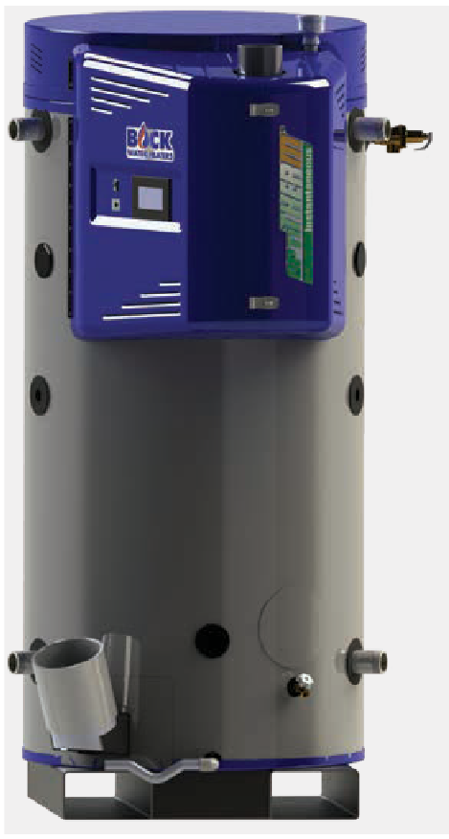Submittal Sheet
OptiTherm® Water Heater
600,000 to 900,000 BTU/hr

Job Name Location Arch./Engr. Wholesaler Mech. Contractor Model No. Gas Type BTU/hr Input Recovery Rate in GPH °F Rise
Notes ASME Construction

OptiTHERM® for Optimal Thermal Efficiency:
- 600/700/800/900,000 BTU Inputs
- 130 gallon tank
- Extremely efficient
  - 99% at Low Fire/98% at High Fire
- New Touch Screen Controls for ease of operation
- Fits through a 36-inch door
- Front intake/exhaust for zero rear clearance
- BACnet/BMS/BOCK Net Remote Access
- Manual reset high limit (field testable)/High-Low Gas Pressure Switches/Optional Low Water Cutoff
- Automatic cathodic corrosion protection system
  - No sacrificial anode rods
- PVC/CPVC/ABS venting - 240' maximum power vent length
- Glass-fused-to-steel water tank and heat exchanger
- SCAQMD certified Ultra-Low NOx
- Natural gas or propane fuel
- Stealth Quiet™ operation
- Built-in pallet jack openings and lifting lugs
Turboflue® High Performance Heat Exchanger:
- Patented helical-fin multi-stage design
- Superior heat conduction and fuel efficiency
Made in the USA

600,000 to 900,000 BTU/hr

OT600N/OT700N/OT800N/OT900N

Storage, Inputs, Recovery & Efficiency
Model | Storage GAL (L) | Max. Rated Input BTU/HR (KW) | Min. Rated Input BTU/HR (KW) | Recovery @ 100°F Rise GAL/HR (L/HR) | 1st Hr. Del. @ 100°F Rise GAL (L) | Thermal Efficiency @ Max Input (%) | Thermal Efficiency @ Min Input (%)
OT600N-A | 130 (492) | 600,000 (175) | 140,000 (41) | 706 (2,675) | 797 (3,017) | 98 | 99
OT700N-A | 130 (492) | 700,000 (205) | 140,000 (41) | 824 (3,121) | 915 (3,464) | 98 | 99
OT800N-A | 130 (492) | 800,000 (235) | 140,000 (41) | 941 (3,567) | 1,032 (3,907) | 98 | 99
OT900N-A | 130 (492) | 900,000 (264) | 140,000 (41) | 1,059 (4,013) | 1,150 (4,353) | 98 | 99
NOTE: OT 600/700/800/900 only ASME and high altitude models available.
Change the suffix from “N” to “LP” to designate liquid propane. “A” denotes ASME construction.

Dimensions and Connections
Model | Dimensions in Inches (cm) |  |  |  |  |  |  |  |  |  | Cold NPT | Hot NPT | Recirc. Return NPT | Gas NPT | Air Intake PVC | Exhaust Vent PVC | Shipping Weight LBS (kg)
 | A | B | C | D | E | F | G | H | I | J
OT600N-A |  |  |  |  |  |  |  |  |  |  | 2" | 2" | 1" | 2" | 6" | 6"
OT700N-A | 78 | 34 | 68 | 15 | 13 | 67 | 78 | 42 | 80 | 83 |  |  |  |  |  |  | 1,700
OT800N-A | (199) | (86) | (173) | (38) | (33) | (170) | (198) | (106) | (203) | (211) |  |  |  |  |  |  | (773)
OT900N-A

T&P valve and brass drain valve factory installed. Standard Voltage (all): 120V, 60 Hz, 1P
Maximum Working Pressure: 150 psi (1034 kPa) These models meet or exceed current ASHRAE standards.

NSF/ANSI 5

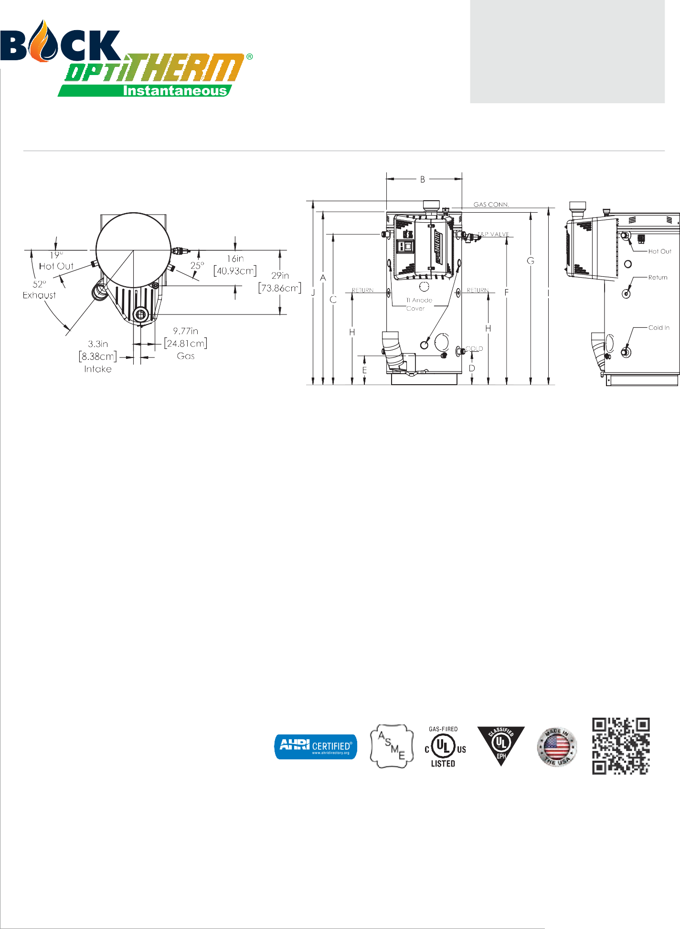Warning: Installation should be in accordance with all national and/or local codes. In the absence of local codes, refer to NFPA 54 or CSA B149.1.
Submittal Sheet
OptiTherm® Water Heater
Caution: The recommended maximum hot water temperature setting for normal residential use is 120°F. Bock recommends a tempering valve or anti-scald valve be installed and used according to the manufacturer’s directions to prevent scalding.

600,000 to 900,000 BTU/hr

Venting (Materials)
Submittal Sheet
OptiTherm® Water Heater

The following materials are approved for use as the vent and combustion air intake piping:
- PVC (DWV, ASTM-D2665 or CSA B181.2) • PVS (Schedule 40, ASTM-D1785 or CSA B137.3)
- PVC (SDR Series, ASTM-D2241 or CSA B137.3) • CPVC (Scedule 40, ASTM-F441 or CSA B137.3)
- CPVC (SDR Series, ASTM-F442) • ABS (Schedule 40, DWV, ASTM-D2661 or CSA B181.1)
- AL29-4C Stainless Steel • PVC IPEX 1738 (UL 1738, ASTM D2665)
NOTE: Use of cellular core PVC (ASTM F891), cellular core CPVC, or Radel (polyphenyl-sulfone) in non-metallic venting systems is prohibited.
Covering non-metallic vent pipe and fittings with thermal insulation is prohibited.
In Canada, check local codes to ensure that SDR series is approved for use, SDR is not approved for all installations in Canada.

The following materials are approved for use for the fittings in the vent and combustion air intake systems:
- PVS (Schedule 40 DWV, ASTM D2665) • CPVC (Scedule 40, ASTM F438)
- ABS (Schedule 40, DWV, ASTM D2661) • AL29-4C Stainless Steel
- PVC IPEX 1738 (UL 1738, ASTM D2665)

Venting (SystemLengths)
Minimum and Maximum Vent Lengths - 6" Pipe
Model | Pipe Arrangement | Minimum Equivalent Pipe Length (per pipe run) |  | Maximum Equivalent Pipe Length (per pipe run)
 |  | Air Intake (ft) | Vent (ft) | Air Intake (ft) | Vent (ft)
OT600N/OT700N/ OT800N/OT900N | Power Direct Vent (2 Pipe) | 20 | 20 | 100 | 100
 | Power Vent (1 Pipe) | 0 | 20 | 0 | 200

Venting (Equivalent Length)
The equivalent straight pipe length of a 90°, 1/4 standard bend elbow and 45°, 1/8 standard bend elbow is 5 feet and 2.5 feet, respectively. DO NOT use short bend elbows.

Gas Pressures (OT600-900)

For natural gas:
MINIMUM GAS SUPPLY PRESSURE (at gas control) = 4" W.C. (dynamic) MAXIMUM GAS SUPPLY PRESSURE (at gas control) = 14" W.C. (static or dynamic)

For LP gas:
MINIMUM GAS SUPPLY PRESSURE (at gas control) = 8" W.C. (dynamic) MAXIMUM GAS SUPPLY PRESSURE (at gas control) = 14" W.C. (static or dynamic)
Note: Dynamic pressure is measured while gas is flowing and static pressure is measured while gas is not flowing.

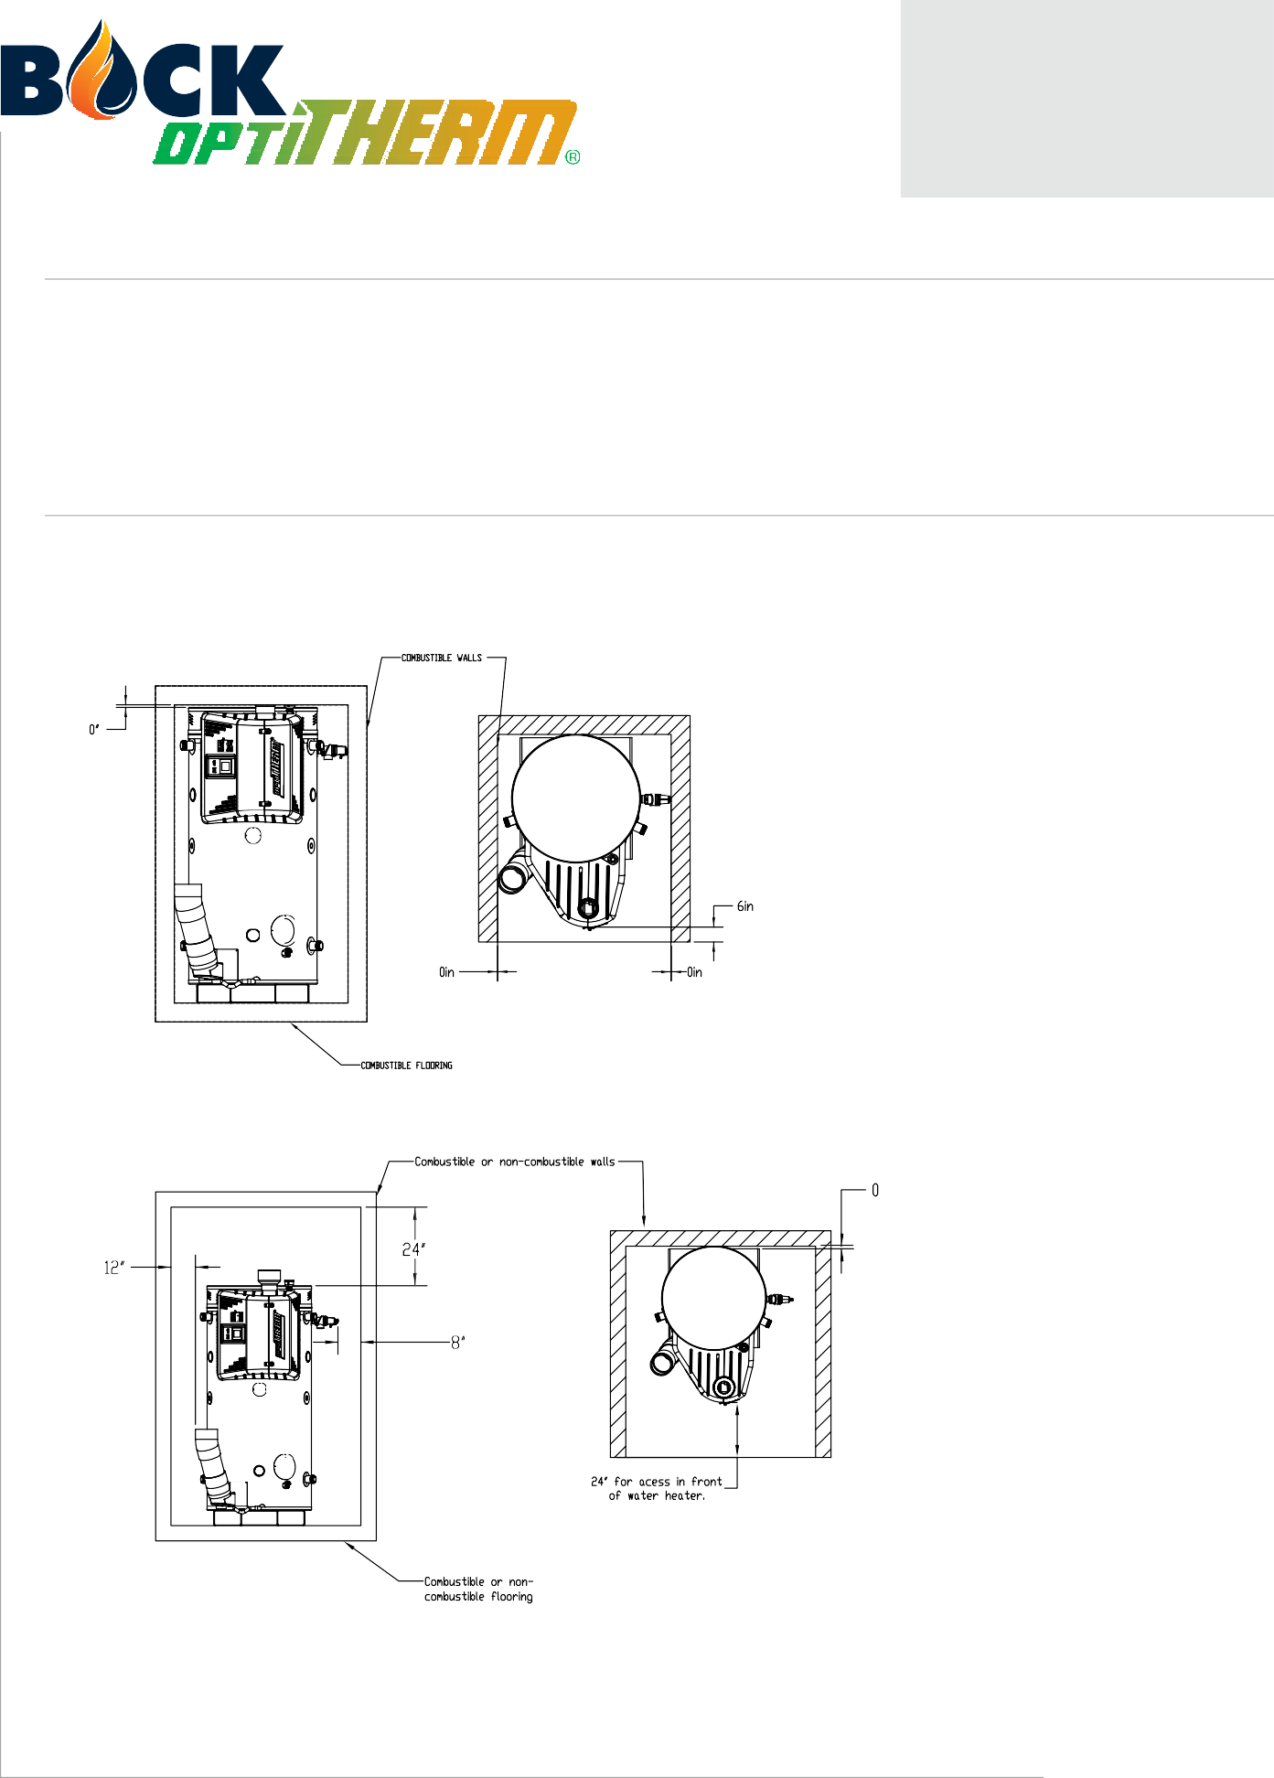

600,000 to 900,000 BTU/hr
Submittal Sheet
OptiTherm® Water Heater

UL Classified
UL classified in accordance with NSF/ANSI 372 - Drinking Water System Components (Lead content) to comply with ≤0.25% lead as required by the Reduction of Lead in Drinking Water Act.
UL classified in accordance with NSF/ANSI 5 – Water Heaters, Hot Water Supply Boilers, and Heat Recovery Equipment.

Clearances (OT600-900)
Minimum clearances from combustible construction: 0" Sides, 0" Back, 0" Top, 6" Front. 0" from vent connector. Approved for alcove installation and combustible flooring.
Minimum access clearances for servicing: 12" Left Side, 8" Right Side, 0" Back, 24" Top, 24" Front.

Minimum Clearance From Combustibles

Required Minimum Access Clearances

www.bockwaterheaters.com
110 South Dickinson Street Madison, Wisconsin 53703
Toll Free 800-794-2491 • Phone 608-257-2225 • Fax 608-257-5304

